Description of Underway pCO₂ System onboard the OOCL Ship Tianjin from September 2008 through February 2010

Under the support of NOAA's Climate Program Office (CPO), the Pacific Marine Environmental Laboratory (PMEL) is collaborating with other NOAA investigators and academic partners to document ocean carbon sources and sinks by outfitting research ships and commercial vessels with automated carbon dioxide sampling equipment to analyze the carbon exchange between the ocean and atmosphere. During the summer of 2008, PMEL deployed an underway pCO₂ system on the Orient Overseas Container Line (OOCL) container ship Tianjin. The OOCL Tianjin regularly travels between Hong Kong and Long Beach, California, an important North Pacific sink region for atmospheric CO₂. Data were collected to determine how ocean circulation and biological photosynthesis interact to control the rate of exchange of carbon dioxide gas between the atmosphere and North Pacific Ocean.

This report documents the underway pCO₂ measurements collected during 8 transits across the North Pacific from September 2008 through February 2010.

Principal Investigator:
Dr. Richard Feely
NOAA/PMEL
7600 Sand Point Way NE
Seattle, WA 98115
(206) 526-6214
Richard.A.Feely@noaa.gov

Data Processing and Quality Control:
Cathy Cosca
NOAA/PMEL
7600 Sand Point Way NE
Seattle, WA 98115
(206) 526-6183
Cathy.Cosca@noaa.gov

System Installation, Maintenance, Troubleshooting:
Geoff Lebon
NOAA/PMEL
7600 Sand Point Way NE
Seattle, WA 98115
(206) 526-6884
Geoffrey.T.Lebon@noaa.gov

Ship Name: OOCL Tianjin
Call Sign: VRAR7
Country: China
Ship Owner: Orient Overseas Container Line

Temporal Coverage:
8 cruises in the North Pacific from Hong Kong to Long Beach, California.
See table below for details on each cruise.

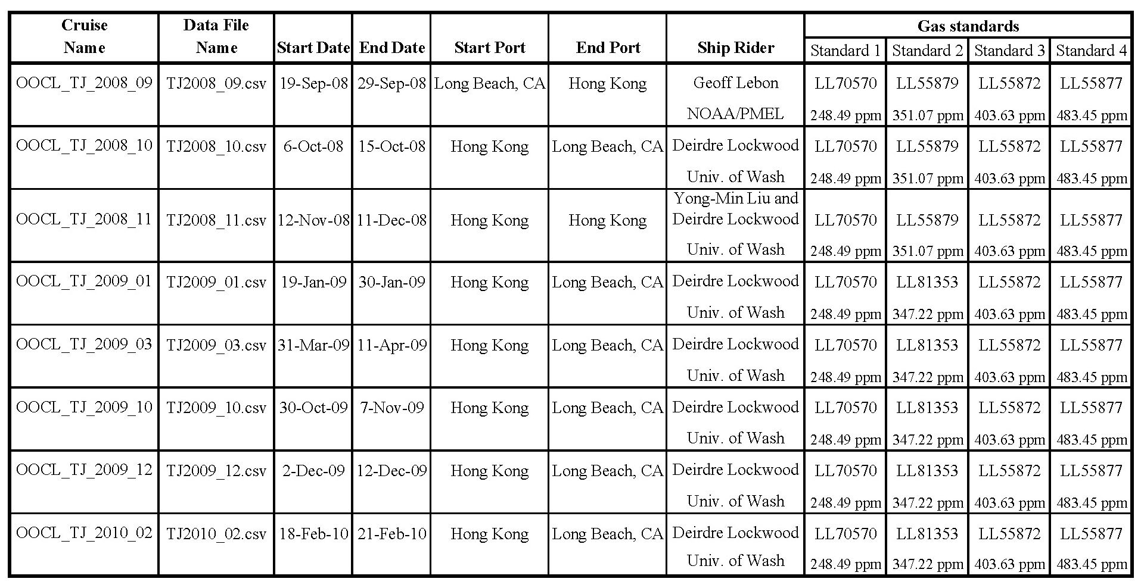

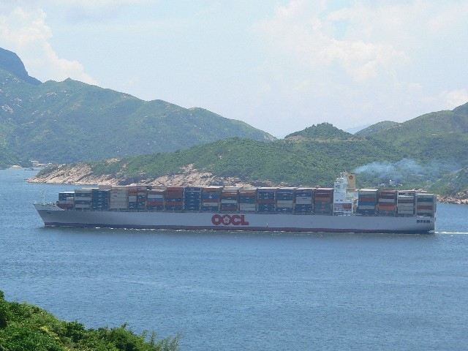

Location of data: www.pmel.noaa.gov/co2/

Experiment Name: Underway measurement of atmospheric and surface water pCO₂

Name/Model of pCO2 System: GO8050, built by General Oceanics.

Method Description:
Equilibrator type/specifications: Showerhead, volume of ~0.5 L with a headspace of ~ 0.8 L.
Water Flow rate: 3.5 L/minute
Headspace gas flow rate: 60 ml/minute
Measurement method: Infrared absorption of dried gas.
CO₂ Sensor: Licor 7000, Serial # IRG4-0586
Resolution/Uncertainty: 0.3 µatm for equilibrator measurements, 0.2 µatm for atmospheric measurements.

Temperature and salinity measurements:
Equilibrator Temperature: Hart Scientific model 1521 digital thermometer, serial number A68850, with an NIST traceable model 5610 thermistor probe, serial number A690607. Accurate to ± 0.01°C.
Sea Surface Temperature: A Seabird SBE 48 Hull mounted temperature probe, serial number 480028, was installed on hull approximately 5m below the sea surface. The SBE 48 was calibrated annually, with a reported accuracy of ± 0.01°C.
Salinity: A Seabird SBE 45 thermosalinograph, serial number 4548581-0238, was mounted next to the underway pCO₂ system in the engine room. The unit was calibrated annually and provided salinity accurate to 0.1.

Pressure measurements: Pressure inside the equilibrator was measured with a Setra 239 differential pressure transducer, accurate to ± 0.15 hPa. The equilibrator was passively vented to a secondary equilibrator, and the Licor sample output was vented to the laboratory when CO2 measurements were made, thus equilibrator headspace pressure was assumed to be laboratory pressure. Pressure in the laboratory was measured with a GE Druck barometer, serial number 3054512, with an accuracy of ± 0.01 %fs.

Standard gases:
Standard gases are supplied by NOAA’s Climate Monitoring Diagnostics Laboratory in Boulder, CO, and are directly traceable to the WMO scale. Any value outside the range of the standards should be considered approximate, although the general trends should be indicative of the seawater chemistry. See attached table for standard concentrations for each cruise.

Sampling Cycle:
The system runs a full cycle in approximately 3 hours. The cycle starts with 4 standard gases, then measures three cylces of 20 surface water measurements followed by 6 atmospheric samples. Each new gas is flushed through the Licor Analyzer for 4 minutes prior to a 10 second reading from the analyzer during which the sample cell is open to the atmosphere. Subsequent samples of the same gas are flushed through the Licor Analyzer for 30 seconds prior to a stop-flow measurement.

Units:
All xCO₂ values are reported in parts per million by volume (ppmv) and fCO₂ values are reported in microatmospheres (µatm) assuming 100 % humidity at the equilibrator temperature.

Calculations:
The measured xCO₂ values are linearly corrected for instrument response using
the standard measurements.

Mixing ratios of dried equilibrated headspace and air are converted to fugacity of CO₂ in surface seawater and water saturated air in order to determine the fCO2. For ambient air and equilibrator headspace the fCO₂a, or fCO₂eq is calculated assuming 100% water vapor content:

fCO₂a/eq = xCO₂a/eq(P-pH₂O)exp(B₁₁+2d₁₂)P/RT

where fCO2a/eq is the fugacity in ambient air or equilibrator, pH₂O is the water vapor
pressure at the sea surface temperature, P is the barometric pressure, T is the
SST or equilibrator temperature (in K) and R is the ideal gas constant
(82.057 cm³·atm·deg⁻¹·mol⁻¹). The exponential term is the fugacity correction where
B₁₁ is the second virial coefficient of pure CO₂

B₁₁ = -1636.75 + 12.0408T - 0.032795T² + 3.16528E-5 T³

and d₁₂ = 57.7 - 0.118 T

is the correction for an air-CO₂ mixture in units of cm³·mol⁻¹ (Weiss, 1974).

The calculation for the fugacity at SST involves a temperature correction term for the
increase of fCO₂ due to heating of the water from passing through the pump and through
5 cm ID PVC tubing within the ship. The water in the equilibrator is typically 0.2 °C
warmer than sea surface temperature. The empirical temperature correction from
equilibrator temperature to SST is outlined in Weiss et al. (1982).

Δln(fCO₂)=(Teq-SST)(0.0317-2.7851E-4 Teq - 1.839E-3 ln(fCO₂eq))

where Δln(fCO₂) is the difference between the natural logarithm of the fugacity at Teq
and SST, and Teq is the equilibrator temperature in degrees C.

A detailed description of calculations and QC procedures can be found in Pierrot et al. (2009).

File Format

COLUMN HEADER DESCRIPTION

1. GROUP/SHIP: PMEL/OOCL_Tianjin

2. CRUISE_ID: Tian_<Year>_<month>

3. JD_GMT: Decimal year day

4. Date_DDMMYYYY Date in the format DDMMYYYY

5. TIME_HH:MM:SS: GMT HH:MM:SS

6. LAT_DEC_DEGREE: Latitude in decimal degrees (negative values are in
southern hemisphere).

7. LONG_DEC_DEGREE: Longitude in decimal degrees (negative values are
in western latitudes).

8. xCO2W_PPM: Mole fraction of CO₂ (dry) in the headspace
equilibrator at equilibrator temperature (Teq) in
parts per million. Water comes from bow intake 5m below the water line.

9 xCO2A_PPM: Mole fraction of CO₂ in air in parts per million.

10 xCO2A_INTERPOLATED_PPM: xCO₂atm_ppm averaged linearly to match up with
measurements xCO₂eq_ppm

11 PRES_EQUIL_hPa: Barometric pressure in the equilibrator

12 PRES_SEALEVEL_hPa: Barometric pressure in the atmosphere

13. EqTEMP_C: Temperature in the equilibrator water.

14. SST(TSG)_C: Temperature from the ship's bow intake.

15. SAL(TSG)_PERMIL: Thermosalinograph salinity

16. fCO2W@SST_uATM: Fugacity of CO₂ in sea water in
microatmospheres calculated as outlined in the DOE Handbook.

17. CO2A_uATM: Fugacity of CO₂ in air in microatmospheres

18. dfCO2_uatm: Sea water fCO₂ - air fCO₂ in microatmospheres.

19. QC_FLAG: Quality control flag 2 = Good value
3 = Questionable value
4 = Bad value

20. QC_SUBFLAG: Descriptive quality control flag used when a value
receives a “3” QC flag
1 = Outside of Standard Range
2 = Questionable/interpolated SST
3 = Questionable EQU temperature
4 = Anomalous ΔT (EqT – SST)( ± 1°C)
5 = Questionable Sea Surface Salinity
6 = Questionable pressure
7 = Low EQU gas flow
8 = Questionable air value
9= Interpolated standard value
10 = Other, see metadata

References

DOE (1994). Handbook of methods for the analysis of the various parameters of the carbon
dioxide system in sea water; version 2. A.G. Dickson and C. Goyet, eds., ORNL/CDIAC-74.
Feely, R.A., R. Wanninkhof, H.B. Milburn, C.E. Cosca, M. Stapp, and P.P. Murphy (1998). A new automated underway system for making high precision pCO₂ measurements onboard research ships, Analytica Chim. Acta, 377, 185-191, 1998.
Pierrot, D., C. Neill, K. Sullivan, R. Castle, R. Wanninkhof, H. Luger, T. Johannessesn, A. Olsen, R. A. Feely, C. E. Cosca (2009). Recommendations for autonomous underway pCO2 measuring systems and data-reduction routines. Deep Sea Research Part II: Topical Studies in Oceanography, Volume 56, Issues 8-10, Pages 512-522.
Wanninkhof, R. and K. Thoning (1993) Measurement of fugacity of CO₂ in surface water using
continuous and discrete sampling methods. Mar. Chem. 44(2-4): 189-205.
Weiss, R. F. (1970) The solubility of nitrogen, oxygen and argon in water and seawater.
Deep-Sea Research 17: 721-735.
Weiss, R. F. (1974) Carbon dioxide in water and seawater: the solubility of a non-ideal gas.
Mar. Chem. 2: 203-215.
Weiss, R. F., R. A. Jahnke and C. D. Keeling (1982) Seasonal effects of temperature and
salinity on the partial pressure of CO₂ in seawater. Nature 300: 511-513.

For questions or comments contact:
Cathy Cosca
NOAA/PMEL
7600 Sand Point Way NE
Seattle, WA 98115
206-526-6183
cathy.cosca@noaa.gov

